Communication With Volante :
----------------------------------------------------------------------------------------------------------
PF-Passbook Entries For Volante Contribution Records:
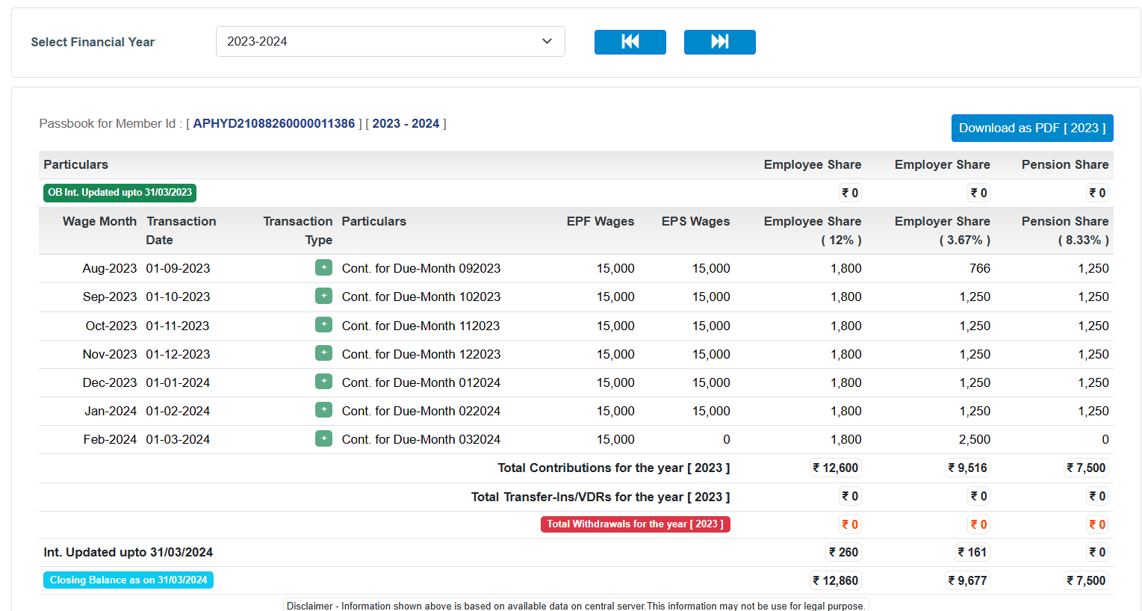

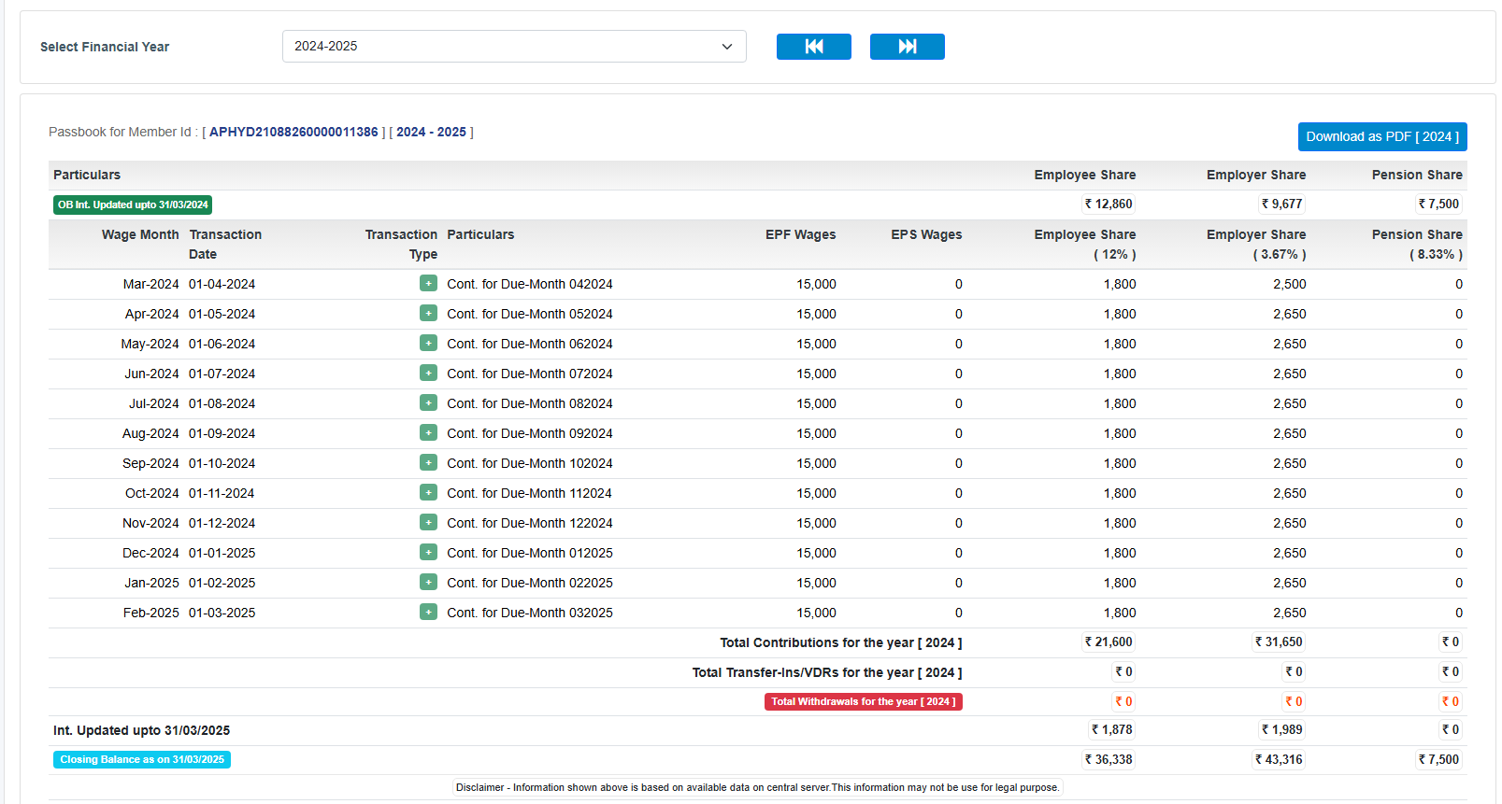

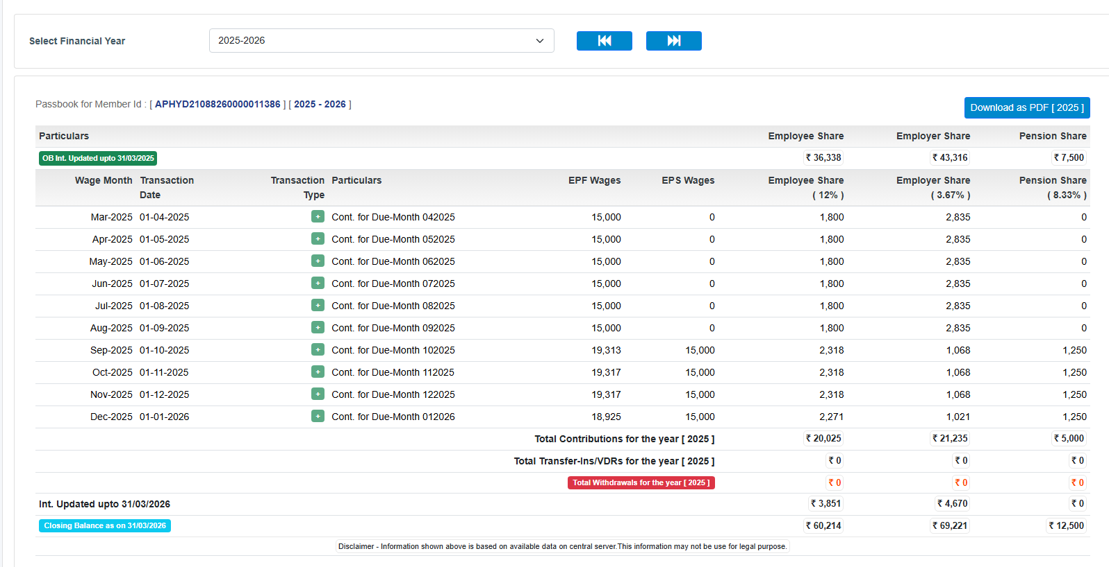

-----------------------------------------------------------------------------------------------------------

Rejected Claim:
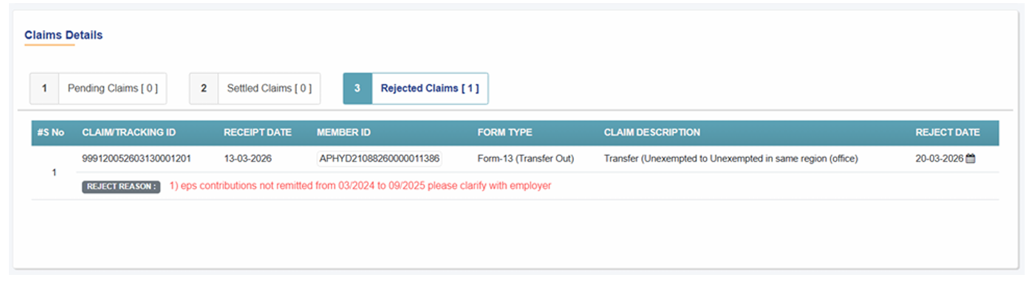
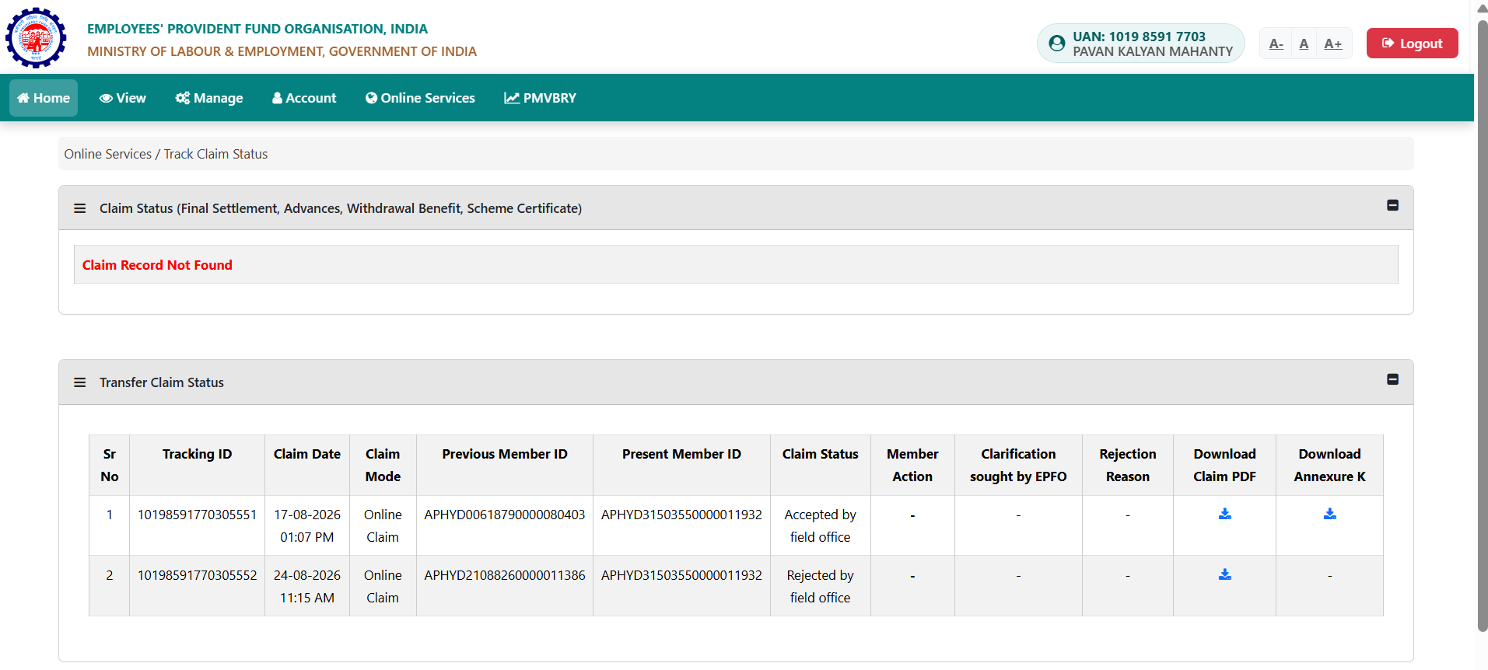

Communication With EPFO :
SOPTC/E/2026/04073 First Grivenace With EPFO
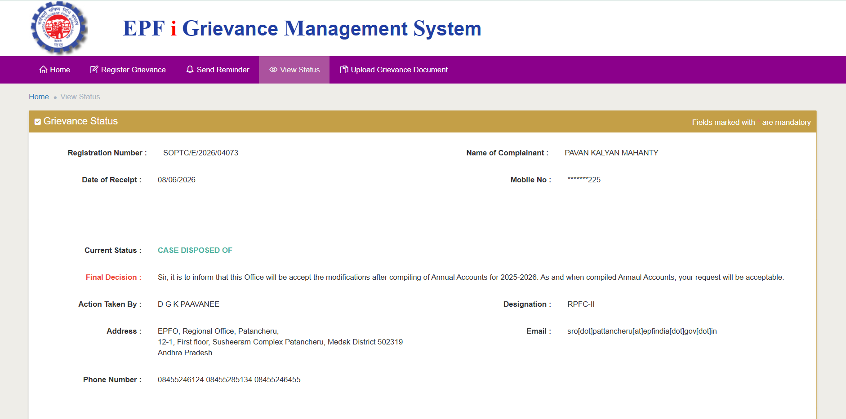
SOPTC/E/2026/06877 Second Grivenace With EPFO
DESCRIPTION:
Personal and PF Details: Name Pavan Kalyan Mahanty, UAN 101985917703, Member ID APHYD21088260000011386, Establishment Volante Technologies India Private Limited, Establishment Code APHYD2108826000, Previous Grievance Ref SOPTC/E/2026/04073.
Background and Issue:
My online EPF transfer request Form 13 was rejected due to missing EPS contributions from March 2024 to September 2025. My former employer Volante Technologies India Pvt Ltd submitted the formal reallocation letter Form 3A with Inward No 40502 to Regional PF Office Patancheru on 20/04/2026. The employer requested reallocation of the statutory portion from EPF head to EPS head.
Current Status:
I previously raised grievance SOPTC/E/2026/04073 and was informed that the update would be processed with annual financial year reconciliation. However it has been over 2 months and the reallocation is still not updated in my passbook. This is blocking my PF transfer.
Requested Relief:
Kindly expedite the manual ledger adjustment and passbook update for Member ID APHYD21088260000011386 based on employer submission dated 20/04/2026. Update my EPS pensionable service and contribution records to enable successful PF transfer.
Thanks
Pavan Kalyan Mahanty,
Mobile 7337010225
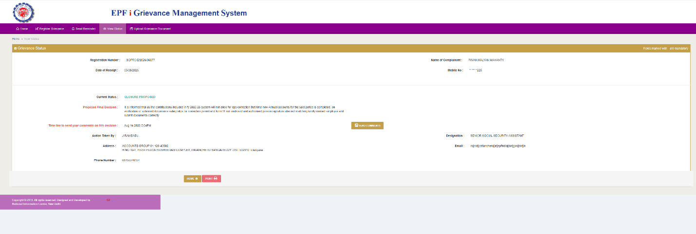
Respected Sir/Madam,
Regarding Member ID APHYD21088260000011386, please note that my former employer Volante Technologies India Pvt Ltd submitted a consolidated bulk application for multiple employees under Inward Reference No. 40502 on 20/04/2026.
The salary slips, Form 11, and supporting documents for all affected employees were submitted together as a single package with that main reference file.
Kindly request you to please re-verify the main file under Inward No. 40502 at Patancheru office where these attachments are enclosed.
Pavan Kalyan Mahanty,
Mobile 7337010225
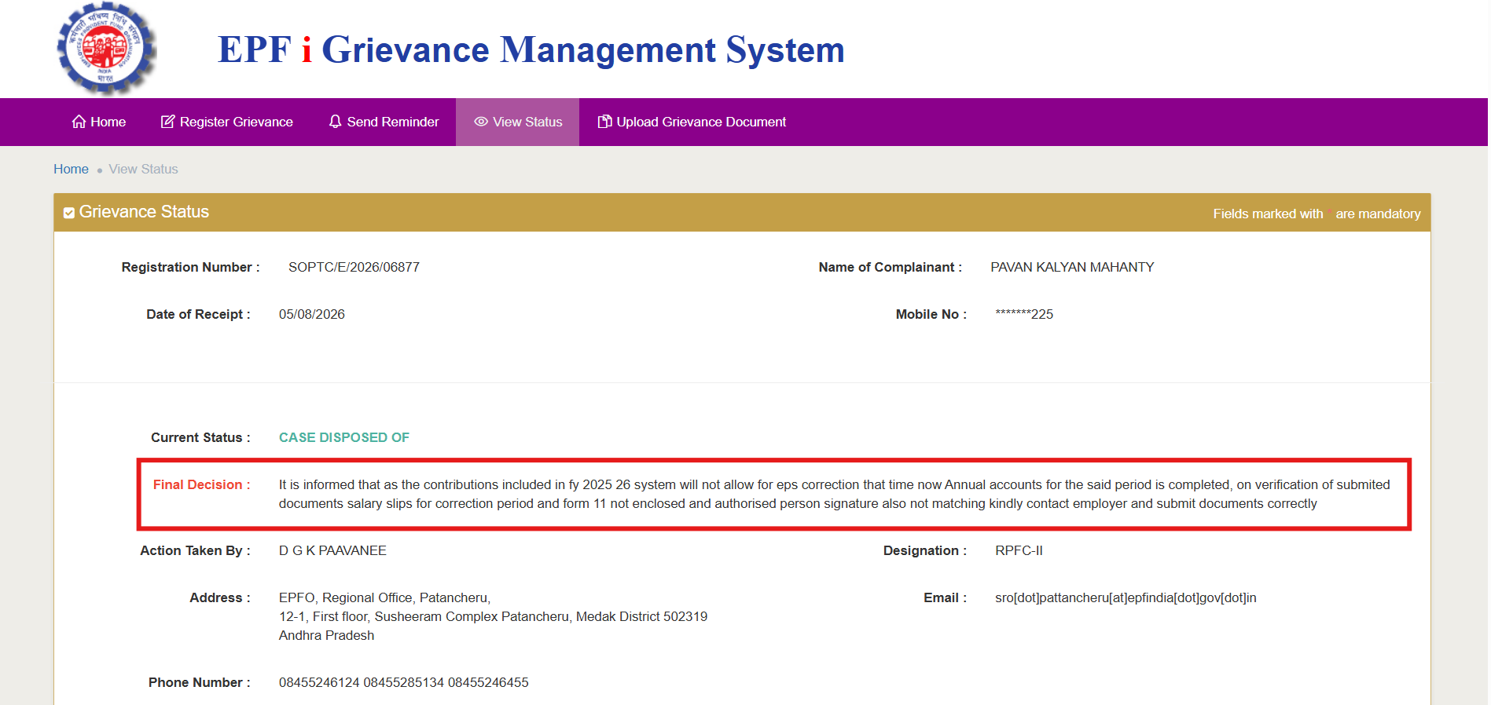

SOPTC/E/2026/08760 Third Grivenace With EPFO
Subject: Request to execute manual ledger adjustment for EPF-to-EPS contribution reallocation (Member ID: APHYD21088260000011386)
Respected Sir/Madam,
I am raising this grievance to request an urgent manual ledger adjustment in my PF passbook to rectify an internal contribution split discrepancy that is currently blocking my online transfer request (Form 13).
My online transfer request was rejected by the field office with the reason: "eps contributions not remitted from 03/2024 to 09/2025 please clarify with employer".
Ledger Breakdown & Clarification:
As verified by my attached passbook entries under Member ID APHYD21088260000011386:
* 03/2024 to 08/2025: My former employer, M/s Volante Technologies India Pvt Ltd, correctly deposited my Employee Share (₹1,800) but inadvertently diverted the entire employer portion (₹2,650) into the EPF Employer Share head, leaving the EPS Pension Share head as "0". This zero-pension ledger balance triggered the system's non-remittance rejection flag.
* 09/2025 to 12/2025: The employer normalized the contribution pattern, resuming the statutory division of ₹1,068 (Employer Share) and ₹1,250 (Pension Share).
Grievance History & Current Rectification:
I previously raised grievances SOPTC/E/2026/04073 and SOPTC/E/2026/06877 regarding this matter. My last grievance was disposed of because the initial bulk presentation (Inward No. 40502) lacked standalone individual validation paperwork, missing standalone salary slips, and missing an updated Form 11.
Following the department's explicit disposal instructions, my former employer has resolved all clerical gaps. They have compiled a complete, standalone individual correction packet and officially submitted it to the Regional Office, Patancheru.
This standalone individual correction application has been successfully submitted and acknowledged by the department. I have attached the official PF Correction Acknowledgement receipt shared by my employer as irrefutable proof of submission.
Requested Relief:
Since the standalone rectification paperwork, individual salary slips, and authenticated company clarifications have now been submitted directly to your office, I request the desk officer to locate this individual submission packet, execute the manual ledger adjustment to reallocate ₹1,250 per month from the EPF Employer Share head to the EPS Pension Share head for the period of 03/2024 to 08/2025, and clear the profile block to let my online transfer complete.
Thank you.
Pavan Kalyan Mahanty
UAN: 101985917703
Mobile: +91 7337010225
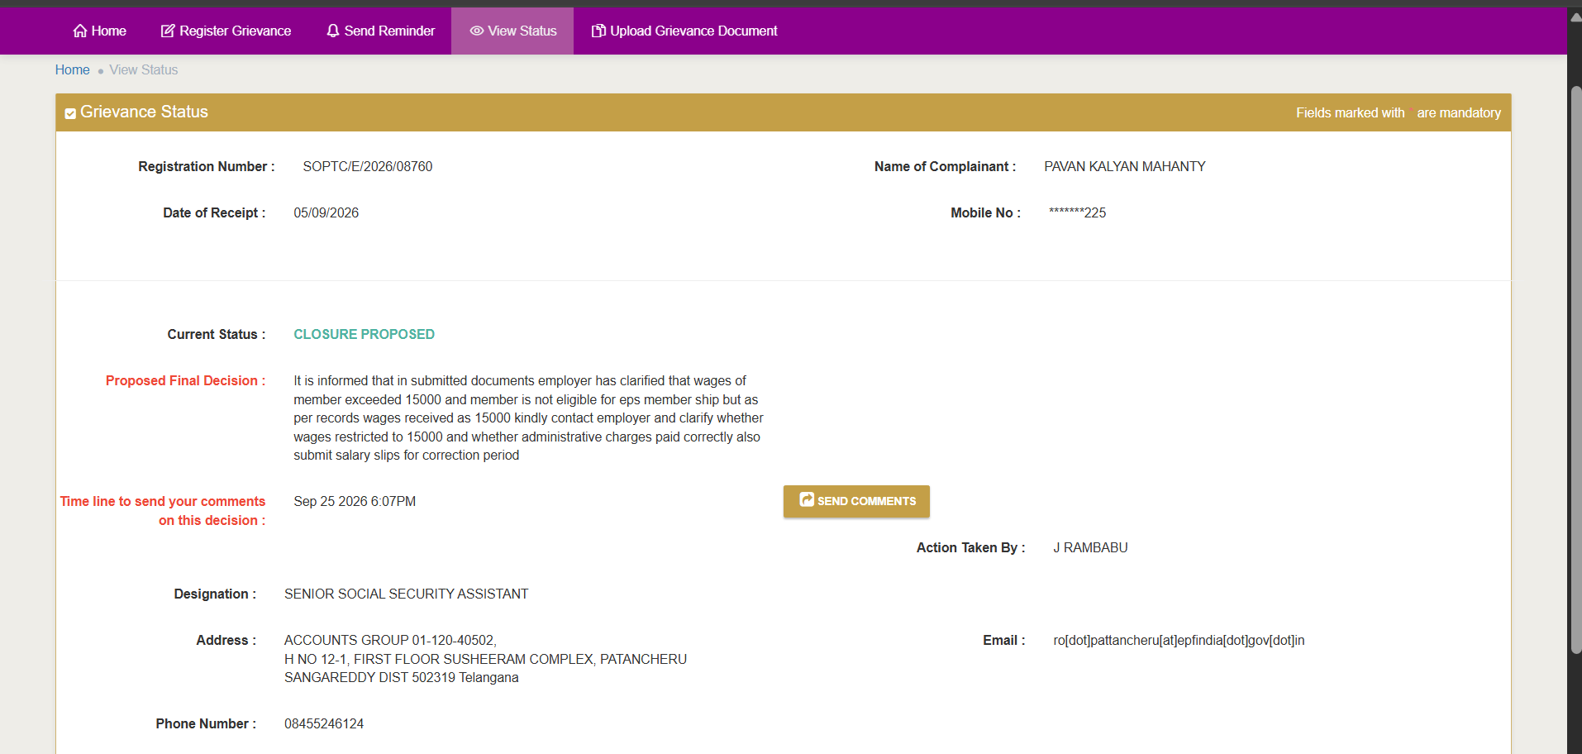

Respected Sir,
Basic wage at joining was 16802 so not restricted to 15000 and non-eligible for EPS.
Required payslips and employer Volante letter dated 25-AUG-2026 are already attached in pfdoc1.pdf.
Employer has requested to transfer EPS funds to EPF Employer Share head.
Requesting you to kindly check pfdoc1.pdf and execute manual ledger adjustment to enable Form-13 transfer.
Regards,
Pavan Kalyan Mahanty,
UAN 101985917703
